Remitido Ruber Piacentini
- NEJM Group: June 13, 2021
ORIGINAL ARTICLE

Convalescent Plasma Antibody Levels and the Risk of Death from Covid-19
List of authors.
- Michael J. Joyner, M.D.,
- Rickey E. Carter, Ph.D.,
- Jonathon W. Senefeld, Ph.D.,
- Stephen A. Klassen, Ph.D.,
- John R. Mills, Ph.D.,
- Patrick W. Johnson, B.S.,
- Elitza S. Theel, Ph.D.,
- Chad C. Wiggins, Ph.D.,
- Katelyn A. Bruno, Ph.D.,
- Allan M. Klompas, M.B., B.Ch., B.A.O.,
- Elizabeth R. Lesser, M.S.,
- Katie L. Kunze, Ph.D.,

Abstract

BACKGROUND
Convalescent plasma has been widely used to treat coronavirus disease 2019 (Covid-19) under the presumption that such plasma contains potentially therapeutic antibodies to severe acute respiratory syndrome coronavirus 2 (SARS-CoV-2) that can be passively transferred to the plasma recipient. Whether convalescent plasma with high antibody levels rather than low antibody levels is associated with a lower risk of death is unknown.

METHODS
In a retrospective study based on a U.S. national registry, we determined the anti–SARS-CoV-2 IgG antibody levels in convalescent plasma used to treat hospitalized adults with Covid-19. The primary outcome was death within 30 days after plasma transfusion. Patients who were enrolled through July 4, 2020, and for whom data on anti–SARS-CoV-2 antibody levels in plasma transfusions and on 30-day mortality were available were included in the analysis.

RESULTS
Of the 3082 patients included in this analysis, death within 30 days after plasma transfusion occurred in 115 of 515 patients (22.3%) in the high-titer group, 549 of 2006 patients (27.4%) in the medium-titer group, and 166 of 561 patients (29.6%) in the low-titer group. The association of anti–SARS-CoV-2 antibody levels with the risk of death from Covid-19 was moderated by mechanical ventilation status. A lower risk of death within 30 days in the high-titer group than in the low-titer group was observed among patients who had not received mechanical ventilation before transfusion (relative risk, 0.66; 95% confidence interval [CI], 0.48 to 0.91), and no effect on the risk of death was observed among patients who had received mechanical ventilation (relative risk, 1.02; 95% CI, 0.78 to 1.32).

CONCLUSIONS
Among patients hospitalized with Covid-19 who were not receiving mechanical ventilation, transfusion of plasma with higher anti–SARS-CoV-2 IgG antibody levels was associated with a lower risk of death than transfusion of plasma with lower antibody levels. (Funded by the Department of Health and Human Services and others; ClinicalTrials.gov number, NCT04338360. opens in new tab.)
Passive antibody transfer has been used to treat infections of the respiratory system for more than a century.¹⁻³ During the 1918 influenza pandemic, this therapeutic approach involved the widespread use of convalescent plasma or serum.⁴ The coronavirus disease 2019 (Covid-19) pandemic has revived interest in the use of convalescent plasma for the treatment of patients with Covid-19. Despite this substantial interest, the efficacy signals are preliminary,^{5,6} and the published results of randomized trials or matched treatment–control studies have been inconclusive.⁷⁻²³
In response to the Covid-19 pandemic, the Mayo Clinic initiated the Covid-19 Convalescent Plasma Expanded-Access Program. The charter of the program was to provide access to and to assess the safety profile of convalescent plasma in patients with this illness, and additional exploratory analyses were performed. In a retrospective cohort study, we tested the hypothesis that the administration of convalescent plasma with high antibody levels would be associated with a lower risk of death than the administration of convalescent plasma with low antibody levels. To address this hypothesis, we evaluated mortality among a subgroup of hospitalized adults with Covid-19 who received transfusions of convalescent plasma and for whom data on anti–severe acute respiratory syndrome coronavirus 2 (SARS-CoV-2) IgG antibody levels in those transfusions were available.

Methods

STUDY DESIGN AND OVERSIGHT
As described previously,^{24,25} the expanded-access program was a national registry of hospitalized adults with Covid-19. All hospitals or acute care facilities in the United States and any physician licensed in the United States were eligible to participate, provided they agreed to adhere to the protocol (available with the full text of this article at NEJM.org) as well as to both federal and state regulations. The protocol was approved by the institutional review board of the Mayo Clinic, and the study was overseen by an independent data and safety monitoring board. Written informed consent was obtained from the patients or legally authorized representatives of the patients, or by means of an emergency consent process for patients with a medical condition that warranted this process. Full details of the study design, conduct, oversight, and analyses are provided in the protocol and statistical analysis plan (also available at NEJM.org).
Table 1.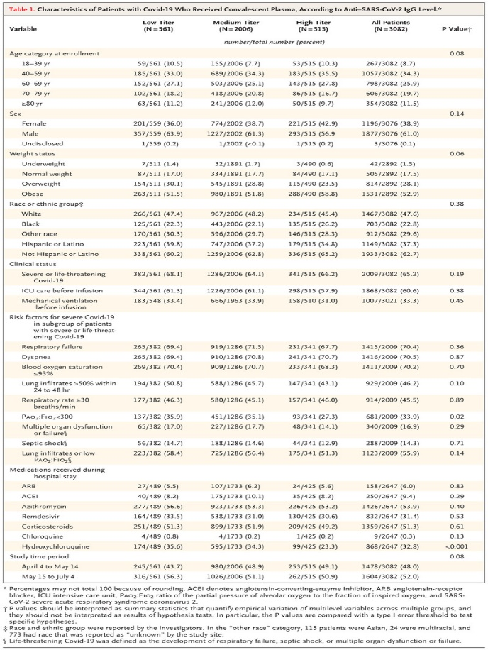Characteristics of Patients with Covid-19 Who Received Convalescent Plasma, According to Anti–SARS-CoV-2 IgG Level.
Eligible patients were 18 years of age or older and were hospitalized with a laboratory-confirmed diagnosis of SARS-CoV-2 infection. These patients also had or were at high risk for progression to severe or life-threatening Covid-19, with high risk defined as the presence of at least one risk factor for severe Covid-19 (see Table 1). The primary outcome of the study was mortality at 30 days after the transfusion of convalescent plasma.

TREATMENT
Convalescent plasma was obtained according to the standardized procedures of blood-collection centers.²⁶ These procedures included the assignment of a standardized identifying number (an International Society of Blood Transfusion [ISBT] 128 code) specific to the donor, and these numbers were used to link anti–SARS-CoV-2 IgG antibody levels with study outcomes corresponding to the plasma recipient or recipients.
One or more units of convalescent plasma were administered intravenously according to individual institutional protocols. The anti–SARS-CoV-2 IgG antibody levels corresponding to plasma units were unknown to the blood-collection centers, investigators, and patients at the time of transfusion.

PROCEDURES
Figure 1.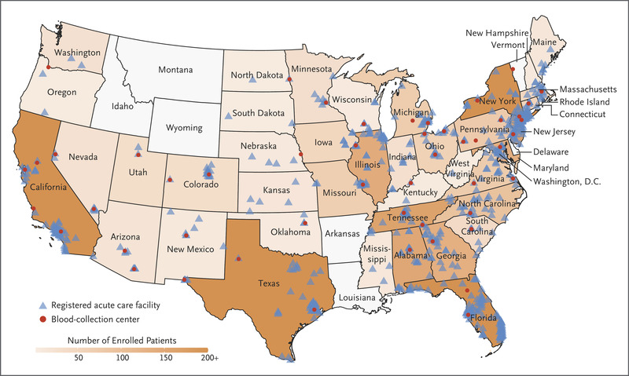Participation in the Covid-19 Convalescent Plasma Expanded-Access Program.
We retrospectively surveyed and solicited blood-collection centers for aliquots of serum from remnant samples retained from the donation process. The shipment of biospecimens to the laboratory at the Mayo Clinic for analysis of antibodies was a voluntary act that was authorized by the institutional review board of the Mayo Clinic, but the shipment was not required. A total of 54 blood-collection centers agreed to ship biospecimens for analysis (Figure 1).
Levels of binding antibodies from serum were assessed with the use of the VITROS Anti–SARS-CoV-2 IgG chemiluminescent immunoassay (Ortho-Clinical Diagnostics) in accordance with the manufacturer’s instructions.²⁷ Although this assay does not differentiate binding IgG antibodies from virus-neutralizing IgG antibodies, a strong correlation has been shown between the amount of antispike protein IgG and in vitro virus neutralization.^{28,29} This IgG chemiluminescent immunoassay is a qualitative assay that is based on the detection of IgG antibodies against a recombinant form of the SARS-CoV-2 spike subunit 1 protein. Numerical results of the assay correspond to the ratio of the sample signal to a calibrator-assigned cutoff signal (the signal-to-cutoff ratio).
Signal-to-cutoff ratios for anti–SARS-CoV-2 IgG antibody levels were categorized as low (<4.62), medium (4.62 to 18.45), or high (>18.45). The cutoff points corresponded approximately to the 20th and 80th percentiles of the distribution for the signal-to-cutoff ratio. The upper threshold for the IgG antibody signal-to-cutoff ratio was selected to provide 90% specificity for the detection of a dilution of the sample of 1:2560 or greater with the use of a new semiquantitative assay developed at the Mayo Clinic (in Rochester, MN). That assay measured the capacity to neutralize a pseudovirus bearing the SARS-CoV-2 spike protein. The 90% specificity was prespecified without knowledge of how the threshold would relate to survival and was selected on the basis of an a priori definition of a “high” antibody concentration (1:2560 was the maximum dilution for the assay). The lower threshold was selected to provide 90% sensitivity to detect neutralizing antibody titers of 1:160 or higher. Since the lower limit of detection of the pseudovirus assay was 1:80, the 1:160 titer was one dilution above the minimal detectable value. Web-based, standardized data-reporting surveys entered into the Research Electronic Data Capture system (REDCap, version 9.1.15; Vanderbilt University)^{30,31} were used to assess the clinical and vital status of the patients, as previously described.^{24,25}

STATISTICAL ANALYSIS
The sample size for this retrospective cohort study could not be determined a priori because of the uncertain number of available remnant samples linked to patient data in the registry. Patients who were enrolled through July 4, 2020, or during the first 3 months of the expanded-access program and for whom data on anti–SARS-CoV-2 antibody levels in plasma transfusions and on 30-day mortality were available were included in this analysis. An imputation program was not applied to the data; differences in sample size because of missing data are reported.
In order to mitigate the potentially confounding effects of the plasma volume transfused and to address the uncertainty of how to classify the antibody levels when more than one unit (potentially from different donors) was transfused, the analyses were restricted to patients who received a single unit of convalescent plasma. The database was maintained by the Mayo Clinic and was locked for this retrospective cohort study report on August 5, 2020.
In the primary analysis, we used a regression approach to estimate the relative risk of death at 30 days as a function of the relative anti–SARS-CoV-2 IgG antibody level (low, medium, or high), with or without adjustment for putative confounding variables and known risk factors for death (e.g., advanced age), particularly those that may have been imbalanced across the antibody levels. In this relative-risk regression model, we used a generalized linear model framework that included a log link and the robust variance estimator to correct for the misspecified variance structure (a Poisson distribution was used to improve convergence). This analysis assumed that all patients who were discharged were alive at day 30. To assess the sensitivity of that assumption, we used a Cox model that included patients who were excluded at discharge. To support these two model-based approaches, a classic stratified analysis based on the pooled Mantel–Haenszel estimator for relative risk was constructed. This approach allowed for stratum-by-stratum estimates of the association to be formed while providing a means to estimate the overall (pooled) association.
In addition, we used a gradient-boosting machine, a type of modern machine-learning algorithm that works on the principle of “weak learners” (i.e., the boosting algorithm begins with a simple classification algorithm and then extends the algorithm through the addition of decision trees to generate a single, comprehensive algorithm with a low error rate). Instead of trying to develop a singular prediction equation to link the antibody levels and adjustment variables with survival, we used an algorithm that builds a series of relatively simple decision trees. This series of trees is differentiated from a method such as random forests in that the trees are not independent — specifically, as the gradient-boosting machine builds a network of relatively simple classification algorithms, the observations that remain incorrectly classified are weighted differentially so that the model can learn subtleties that may be present in the data. Although each method was distinct in approach, each attempted to account for potential confounding and risk modification with the use of different statistical techniques.
We also examined patient subgroups that were selected on the basis of historical experience with convalescent plasma, and in adjusted models we chose variables that were similar to those in trials of other therapeutic agents for Covid-19.^{32,33} Mechanical-ventilation status has emerged as a key factor in determining the effectiveness of leading therapeutic agents for Covid-19, including dexamethasone³⁴ and remdesivir,³² and we used it to dichotomize the cohort for subgroup analyses.
Analyses were performed with the use of R software (R Core Team).³⁵ Descriptive statistics are presented as frequencies and percentages. The interpretation of the findings was based on the 95% confidence intervals for the estimated measures of association. For analyses of time to transfusion, the point estimates for mortality were estimated at day 30 on the basis of crude mortality and confidence intervals for binomial proportions calculated with the use of the Wilson method. The widths of the confidence intervals were not adjusted for multiplicity, so the intervals should not be used to infer definitive treatment effects. Reported P values are two-sided. Additional details about the statistical analyses are provided in the Supplementary Statistical Methods section of the Supplementary Appendix (available at NEJM.org).

Results

PATIENTS
The cohort consisted of 3082 patients from 680 acute care facilities across the United States (Figure 1). Table 1 shows key characteristics of the patients, stratified into three groups according to anti–SARS-CoV-2 IgG antibody levels (based on signal-to-cutoff ratios). Overall, 61% of the patients were men, 23% were Black, 37% were Hispanic, 69% were younger than 70 years of age, and two thirds had received transfusions before invasive mechanical ventilation. The median number of patients per site was 2 (interquartile range, 1 to 6). The maximum number of patients from any single site was 59. As shown in Table 1, the three groups (patients who received plasma transfusions with high, medium, and low IgG antibody levels) were generally similar in terms of demographic characteristics, risk factors associated with severe Covid-19, and concomitant use of therapeutic agents for Covid-19. The percentages of patients with hypoxemia and concomitant use of hydroxychloroquine (both of which were variables that were included in adjustment models) were lower in the high-titer group than in the other two groups.

PRIMARY OUTCOME
Table 2.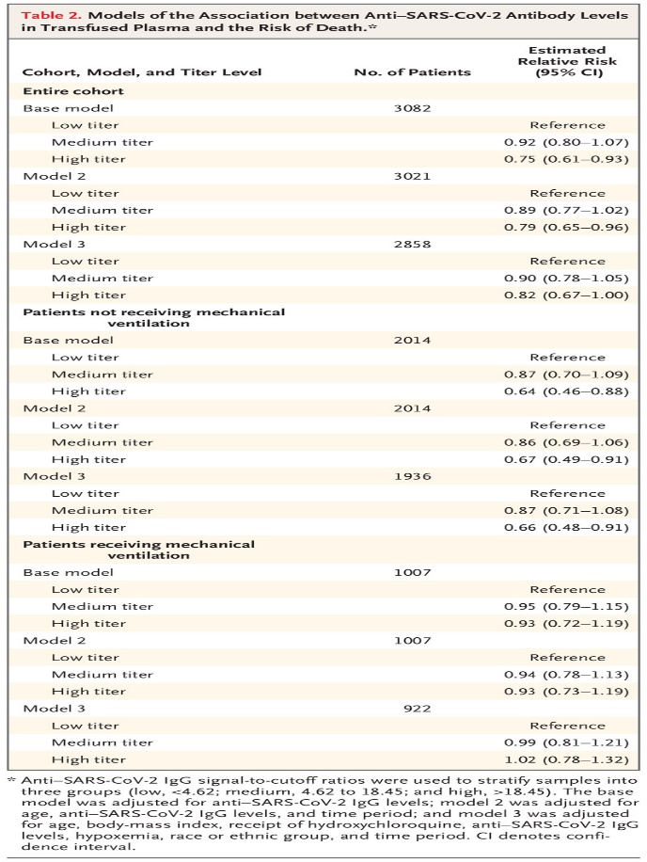Models of the Association between Anti–SARS-CoV-2 Antibody Levels in Transfused Plasma and the Risk of Death.
Death within 30 days after plasma transfusion occurred in 26.9% of all the patients (830 of 3082 patients; 95% confidence interval [CI], 25.4 to 28.5). This primary-outcome event occurred in 29.6% (166 of 561 patients) in the low-titer group, 27.4% (549 of 2006 patients) in the medium-titer group, and 22.3% (115 of 515 patients) in the high-titer group. Patients in the high-titer group had a lower relative risk of death within 30 days after transfusion than patients in the low-titer group (relative risk, 0.75; 95% CI, 0.61 to 0.93) (Table 2). Additional analyses with adjustment for patient demographic characteristics (age, weight status, and race) and clinical characteristics (receipt of invasive mechanical ventilation, use of concomitant therapeutics, and hypoxemia) were conducted to evaluate the overall effect of the anti–SARS-CoV-2 IgG antibody level on the risk of death within 30 days after transfusion (Table S1 in the Supplementary Appendix). The adjusted models (as defined in Table 2) generally showed a similar association — a lower relative risk of death among patients who received plasma transfusions with high anti–SARS-CoV-2 IgG antibody levels (model 2, relative risk, 0.79 [95% CI, 0.65 to 0.96], and model 3 [with additional adjustment], relative risk, 0.82 [95% CI, 0.67 to 1.00]) (Table 2). The findings of the sensitivity analysis in which patients were excluded at discharge were qualitatively similar to each of these findings.

SUBGROUP ANALYSIS
Table 3.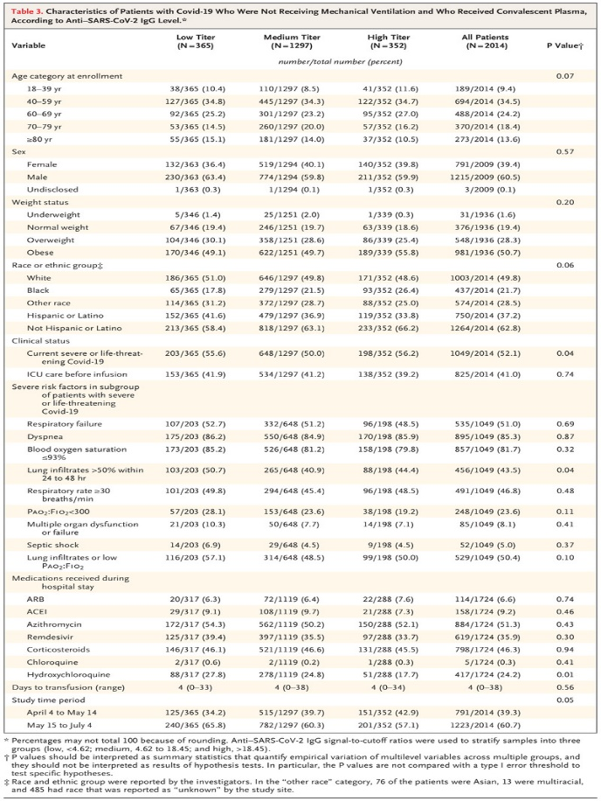Characteristics of Patients with Covid-19 Who Were Not Receiving Mechanical Ventilation and Who Received Convalescent Plasma, According to Anti–SARS-CoV-2 IgG Level.
In the cohort of 3082 patients, 2014 patients did not receive mechanical ventilation before transfusion. Table 3 shows key patient characteristics of the subgroup of patients who were not receiving mechanical ventilation, stratified according to anti–SARS-CoV-2 IgG antibody levels. In the subgroup of patients who were not receiving mechanical ventilation, death within 30 days after plasma transfusion occurred in 81 of 365 patients (22.2%; 95% CI, 18.2 to 26.7) in the low-titer group, 251 of 1297 patients (19.4%; 95% CI, 17.3 to 21.6) in the medium-titer group, and 50 of 352 patients (14.2%; 95% CI, 10.9 to 18.2) in the high-titer group; Table S4 shows these results in the subgroup of patients who were receiving mechanical ventilation. In the subgroup of patients who were receiving mechanical ventilation, death within 30 days after plasma transfusion occurred in 80 of 183 patients (43.7%; 95% CI, 36.7 to 51.0) in the low-titer group, 277 of 666 patients (41.6%; 95% CI, 37.9 to 45.4) in the medium-titer group, and 64 of 158 patients (40.5; 95% CI, 33.2 to 48.3) in the high-titer group. In both subgroups, the characteristics of the patients were well balanced across the three antibody-titer groups.
In the fully adjusted relative risk regression model, the lower risk of death within 30 days after plasma transfusion in the high-titer group than in the low-titer group was observed among patients who were not receiving mechanical ventilation before transfusion (relative risk, 0.66; 95% CI, 0.48 to 0.91). No effect on mortality was observed among patients who received mechanical ventilation before transfusion (relative risk, 1.02; 95% CI, 0.78 to 1.32).
Table S2 shows relative-risk regression with or without full adjustment for patient demographic characteristics, anti–SARS-CoV-2 IgG antibody levels, clinical characteristics, and study time period, including all three models (the base model, model 2, and model 3), for the subgroup of patients who were not receiving mechanical ventilation. Table S3 shows relative-risk regression for the subgroup of patients who were receiving mechanical ventilation.
Figure 2.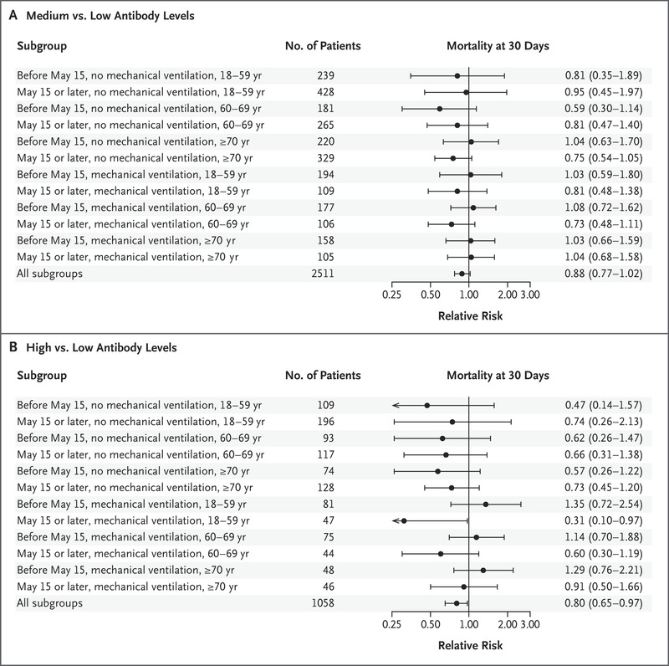Relative Risk of Death within 30 Days after Convalescent Plasma Transfusion.
These findings were further supported by a stratified-data analytic approach that provided direct analytic control for the key variables associated with the risk of death (age, receipt of invasive mechanical ventilation, and study time period) (Figure 2). The pooled (or common) relative risk of death among all the patients within 30 days after plasma transfusion in the high-titer group, as compared with the low-titer group, was 0.80 (95% CI, 0.65 to 0.97) (Figure 2). Figure S1 shows the risk of death within 7 days after transfusion of convalescent plasma, as determined with this stratified data analytic approach.

EXPLORATORY ANALYSES
Among patients who received mechanical ventilation before transfusion, the mean (±SD) number of days between the diagnosis of Covid-19 and the transfusion of convalescent plasma was 10.0±7.7; this was nearly double the mean number of days among patients who were not receiving mechanical ventilation (5.4±4.8). The unadjusted mortality within 30 days after transfusion was lower among patients who received a transfusion within 3 days after receiving a diagnosis of Covid-19 (point estimate, 22.2%; 95% CI, 19.9 to 24.8) than among those who received a transfusion 4 or more days after receiving a diagnosis of Covid-19 (point estimate, 29.5%; 95% CI, 27.6 to 31.6). In model 3, the replacement of ventilation status with a binary classification of days to transfusion resulted in a relative risk of death of 1.18 (95% CI, 1.04 to 1.35) among patients who received a transfusion 4 or more days after receiving the diagnosis. This effect size was lower than that observed in patients who had previously received mechanical ventilation in model 3 (relative risk, 2.16; 95% CI, 1.90 to 2.46).
The trained gradient-boosting machine was used to estimate the relationship between key variables associated with risk of death within 30 days after plasma transfusion and mortality at 30 days. Two methods were used to explore how this machine-learning technique linked the key variables with the mortality predictions.
In the first method, a variable importance plot was generated for each variable included in the model (Fig. S2). The “importance” of the variable is the relative amount by which it improves the prediction, both in terms of location in the decision trees (where more observations are classified higher up in the decision tree) and in the number of times it is used in the collection of trees. The primary variables associated with a risk of death at 30 days were age; evidence of an advanced clinical course of Covid-19, such as the receipt of invasive mechanical ventilation and admission to an intensive care unit (ICU); and the anti–SARS-CoV-2 antibody level, in order of variable importance.
The second method used to explore the association between a given variable and prediction of mortality was by means of a partial dependence plot. The partial dependence plot shows that after adjustment for all other variables included in the model, anti–SARS-CoV-2 IgG antibody levels maintained an inverse relationship with the risk of death. Figure S3 shows similar partial dependence plots for the primary analysis model in which the antibody levels were treated as a continuous variable with the use of a natural spline with four evenly spaced knots. In this model, the partial dependence plot for the overall sample aligned closely with the pattern observed in the gradient-boosting machine model. The inverse relationship with antibody levels was again observed in the patients who were not receiving mechanical ventilation, and there was a general lack of a clear association in these patients.

Discussion
In a retrospective study based on a national registry, convalescent plasma was identified as a potentially beneficial therapy in hospitalized patients with Covid-19. Our principal finding was that among patients with Covid-19 who were not receiving mechanical ventilation, the transfusion of plasma with high antibody levels was associated with a lower risk of death than the transfusion of plasma with low antibody levels. We found no such relationship (between antibody level and the risk of death) among patients with Covid-19 who were receiving mechanical ventilation. In addition, patients who received plasma within 3 days after receiving a diagnosis of Covid-19 had a lower risk of death than those who received transfusions later in the disease course.
These data were consistent with a mortality benefit associated with high-titer plasma administered earlier in the course of the disease. Our findings parallel the recent findings from a trial of the antiviral agent remdesivir in which clinical benefit was evident among patients who were not receiving advanced respiratory support and absent among patients who were receiving noninvasive high-flow oxygen or mechanical ventilation.^{32,36,37} Our findings are also consistent with aggregate data from observational studies and randomized trials of convalescent plasma,^{7,9,38,39} as well as with historical evidence regarding antibody therapy for infectious diseases.³ Our data and those from other studies provide support for the use of anti–SARS-CoV-2 antibody assays as an indicator of the potency of Covid-19 convalescent plasma.
Although patient age was not the primary focus of these analyses, it was estimated to be the most important variable in predicting the risk of death within 30 days after plasma transfusion. The next two most important correlates of this risk — receipt of invasive mechanical ventilation and admission to the ICU — occur late in the course of the disease, when the level of antibodies in the transfused plasma does not appear to affect the risk of death.
Numerous challenges that were encountered during this program were similar to those enumerated elsewhere.³² To overcome these contextual challenges during a pandemic,⁴⁰ we developed a streamlined registration and data-collection system with oversight from a centralized institutional review board. However, several limitations resulted from this design, including limited participation in this retrospective cohort study, limited availability of data owing to the use of abbreviated data-collection forms, the lack of precision in details regarding the temporal relationship between concomitant medication use and transfusion, and missing data (a problem inherent to a national registry). We determined a priori that the low-titer group may have been at higher risk for death than the high-titer group. In addition, the interpretation of these results is limited by the open-label design and the lack of a randomized placebo (control) group. Finally, the study enrollment progressed quickly, and this article was prepared before the second surge of patients had been entered into the expanded-access program (Fig. S4). Although the overall program eventually enrolled more than 105,000 patients — including nearly 94,000 patients who received transfusions — only one third of the data were available for these analyses. Further efforts to obtain antibody data on a larger cohort of patients in the expanded-access program are under way.
These findings were an important component of the scientific evidence considered by the Food and Drug Administration in the decision on August 23, 2020, to issue an emergency-use authorization for convalescent plasma in the treatment of hospitalized adults with Covid-19.⁴¹ Convalescent plasma has also received full or conditional approval in several other countries since that time.
Our analyses show that among patients with Covid-19 who were not receiving mechanical ventilation, the transfusion of plasma with high antibody levels was associated with a lower risk of death than the transfusion of plasma with low antibody levels. In addition, patients who received plasma within 3 days after the diagnosis of Covid-19 had a lower risk of death than those who received a transfusion later in the disease course. These data show that the benefit of convalescent plasma was most apparent in patients who received plasma transfusions containing higher levels of anti–SARS-CoV-2 IgG antibodies early in the disease course.
Supported by a contract (75A50120C00096) from the Department of Health and Human Services, the Office of the Assistant Secretary for Preparedness and Response, and BARDA; grants (UL1TR002377) from the National Center for Advancing Translational Sciences, (5R35HL139854, to Dr. Joyner; 1F32HL154320, to Dr. Senefeld; 5R35HL139854S1, to Mr. Clayburn; and RO1 HL059842, to Dr. Casadevall) from the National Heart, Lung, and Blood Institute, (PDF-532926-2019, to Dr. Klassen) from the Natural Sciences and Engineering Research Council of Canada, (5T32DK07352, to Dr. Wiggins) from the National Institute of Diabetes and Digestive and Kidney Diseases, (R21 AI145356, R21 AI152318, and R21 AI154927, to Dr. Fairweather; and R01 AI152078 9, to Dr. Casadevall) from the National Institute of Allergy and Infectious Diseases, and (U54AG044170, to Dr. Baker) from the National Institute on Aging; and donations from the UnitedHealth Group, National Basketball Association, Millennium Pharmaceuticals, Octapharma USA, Mayo Clinic, and (from Eric E. Schmidt and Wendy Schmidt) the Schwab Charitable Fund.
Disclosure forms provided by the authors are available with the full text of this article at NEJM.org.
Drs. Joyner, Carter, and Senefeld and Drs. Paneth, Fairweather, Wright, and Casadevall contributed equally to this article.
The views and opinions expressed in this article are those of the authors and do not necessarily reflect the official policy or position of the Department of Health and Human Services and its agencies, including the Biomedical Advanced Research and Development Authority (BARDA) and the Food and Drug Administration, as well as any other agency of the U.S. Government. Assumptions made within and interpretations from the analysis do not necessarily reflect the position of any U.S. Government entity.
This article was published on January 13, 2021, at NEJM.org.
A data sharing statement provided by the authors is available with the full text of this article at NEJM.org.
We thank the participating medical centers, medical teams, and blood centers for their rigorous efforts that made this program possible and the donors for providing Covid-19 convalescent plasma.

Author Affiliations
From the Departments of Anesthesiology and Perioperative Medicine (M.J.J., J.W.S., S.A.K., C.C.W., A.M.K., M.A.S., J.C.D.S., S.E.B., J.R.A.S., V.H., A.J.C., J.G.R., K.J.A., M.N.P.V., J.J.D., R.J.R.), Laboratory Medicine and Pathology (J.R.M., E.S.T., C.M.B., J.L.W., J.R.S.), and Cardiovascular Medicine (R.F.R., K.F.L., R.S.W.), the Human Research Protection Program (R.S.W.), and the Department of Internal Medicine, Division of Pulmonary and Critical Care Medicine (P.R.B.), Mayo Clinic, Rochester, MN; the Departments of Health Sciences Research (R.E.C., P.W.J., E.R.L., D.O.H.) and Cardiovascular Medicine (K.A.B., E.R.W., D.F.), Mayo Clinic, Jacksonville, FL; the Department of Health Sciences Research (K.L.K., M.R.B.) and the Department of Internal Medicine, Division of Infectious Diseases (J.E.B.), Mayo Clinic, Phoenix, AZ; the Department of Anesthesiology, Cooper Medical School of Rowan University, Cooper University Health Care, Camden, NJ (N.H.); the Center for Biologics Evaluation and Research, Food and Drug Administration, Silver Spring (N.C.V., P.M.), and the Department of Molecular Microbiology and Immunology, Johns Hopkins Bloomberg School of Public Health, Baltimore (A.C.) — both in Maryland; and the Departments of Epidemiology and Biostatistics and of Pediatrics and Human Development, College of Human Medicine, Michigan State University, East Lansing (N.S.P.).
Address reprint requests to Dr. Joyner at the Department of Anesthesiology and Perioperative Medicine, Mayo Clinic, 200 First St. SW, Rochester, MN 55905, or at joyner.michael@mayo.edu.

